1. Create appropriate Azure resources to utilize Application Insights and Azure Log Analytics.

As evidence, provide a screenshot of the resource group containing your running resources.

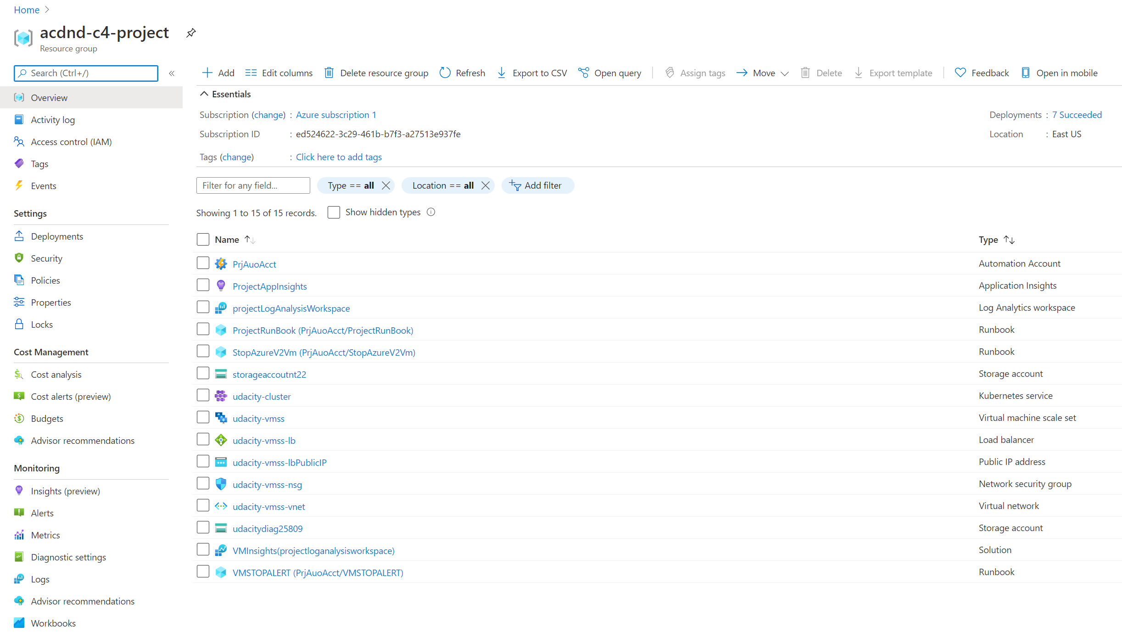

1. Enable Application Insights for a VM Scale Set.

As evidence, provide a screenshot of the metrics from the VM Scale Set instance. This should show the following information:

* CPU %
* Available Memory %
* Information about the Disk
* Information about the bytes sent and received.

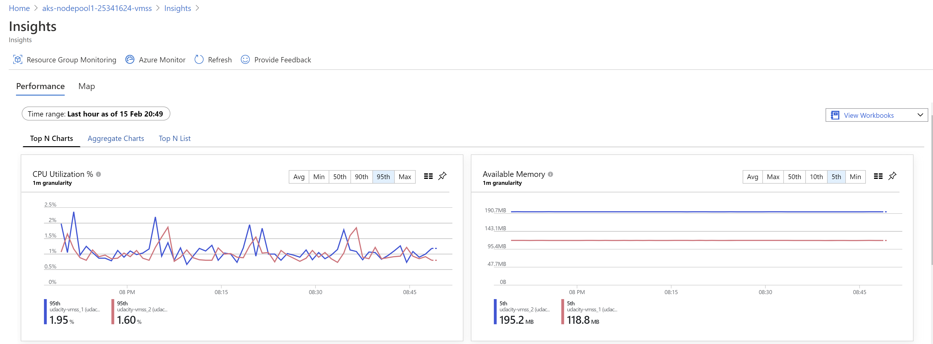

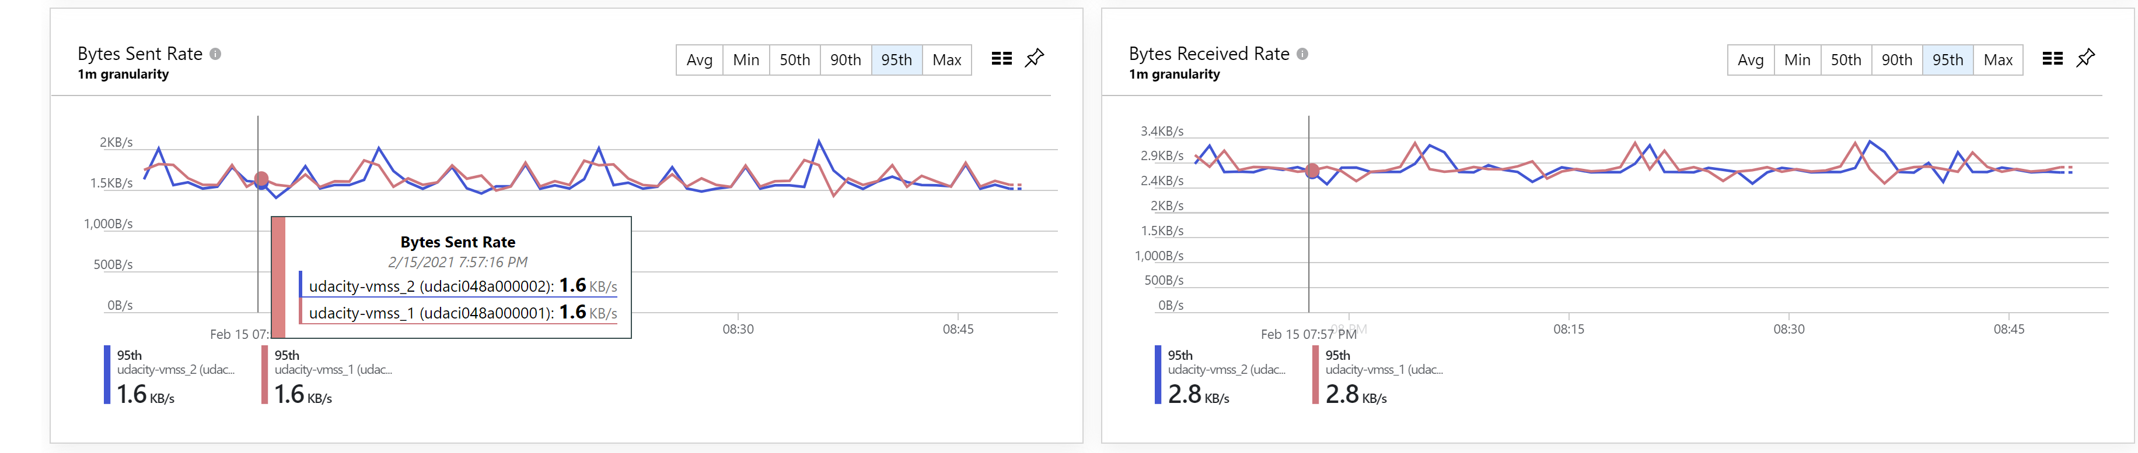

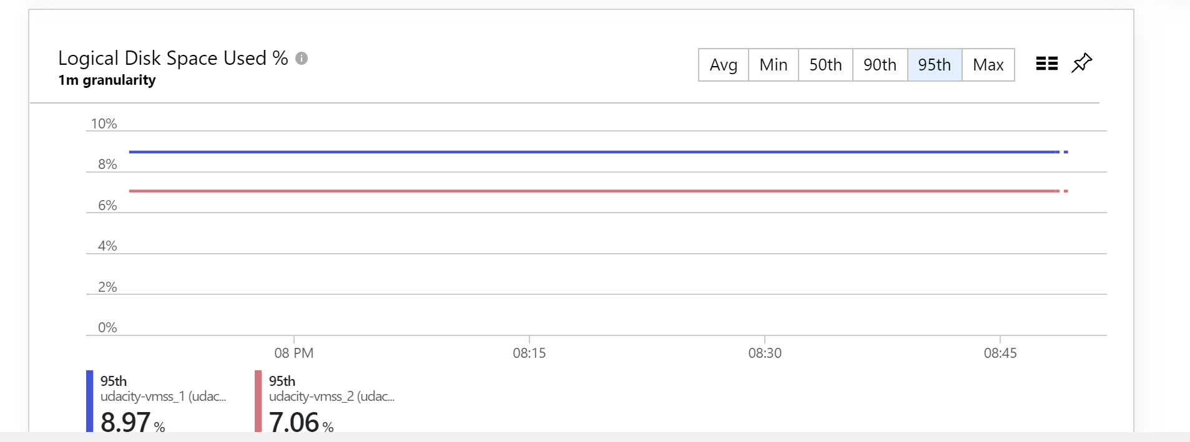

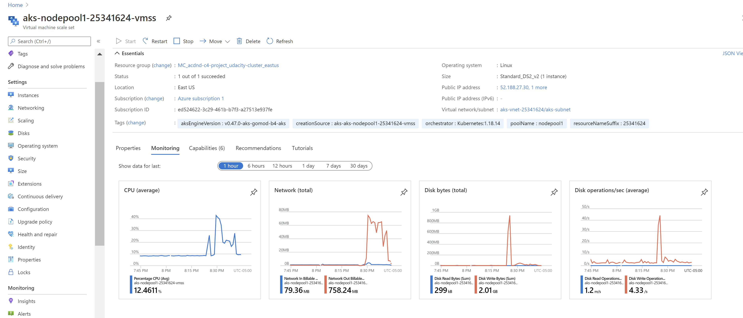

1. As evidence, provide a screenshot showing Application Insights is enabled on the AKS cluster. 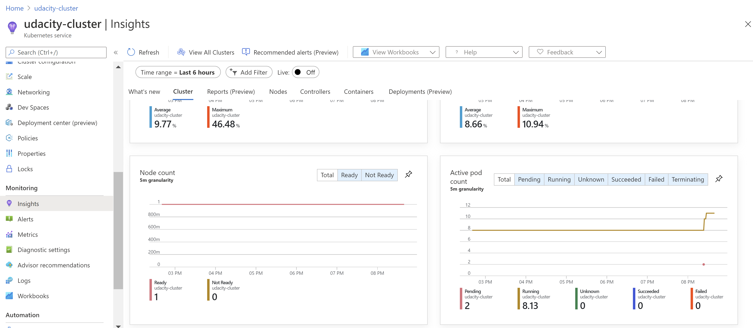

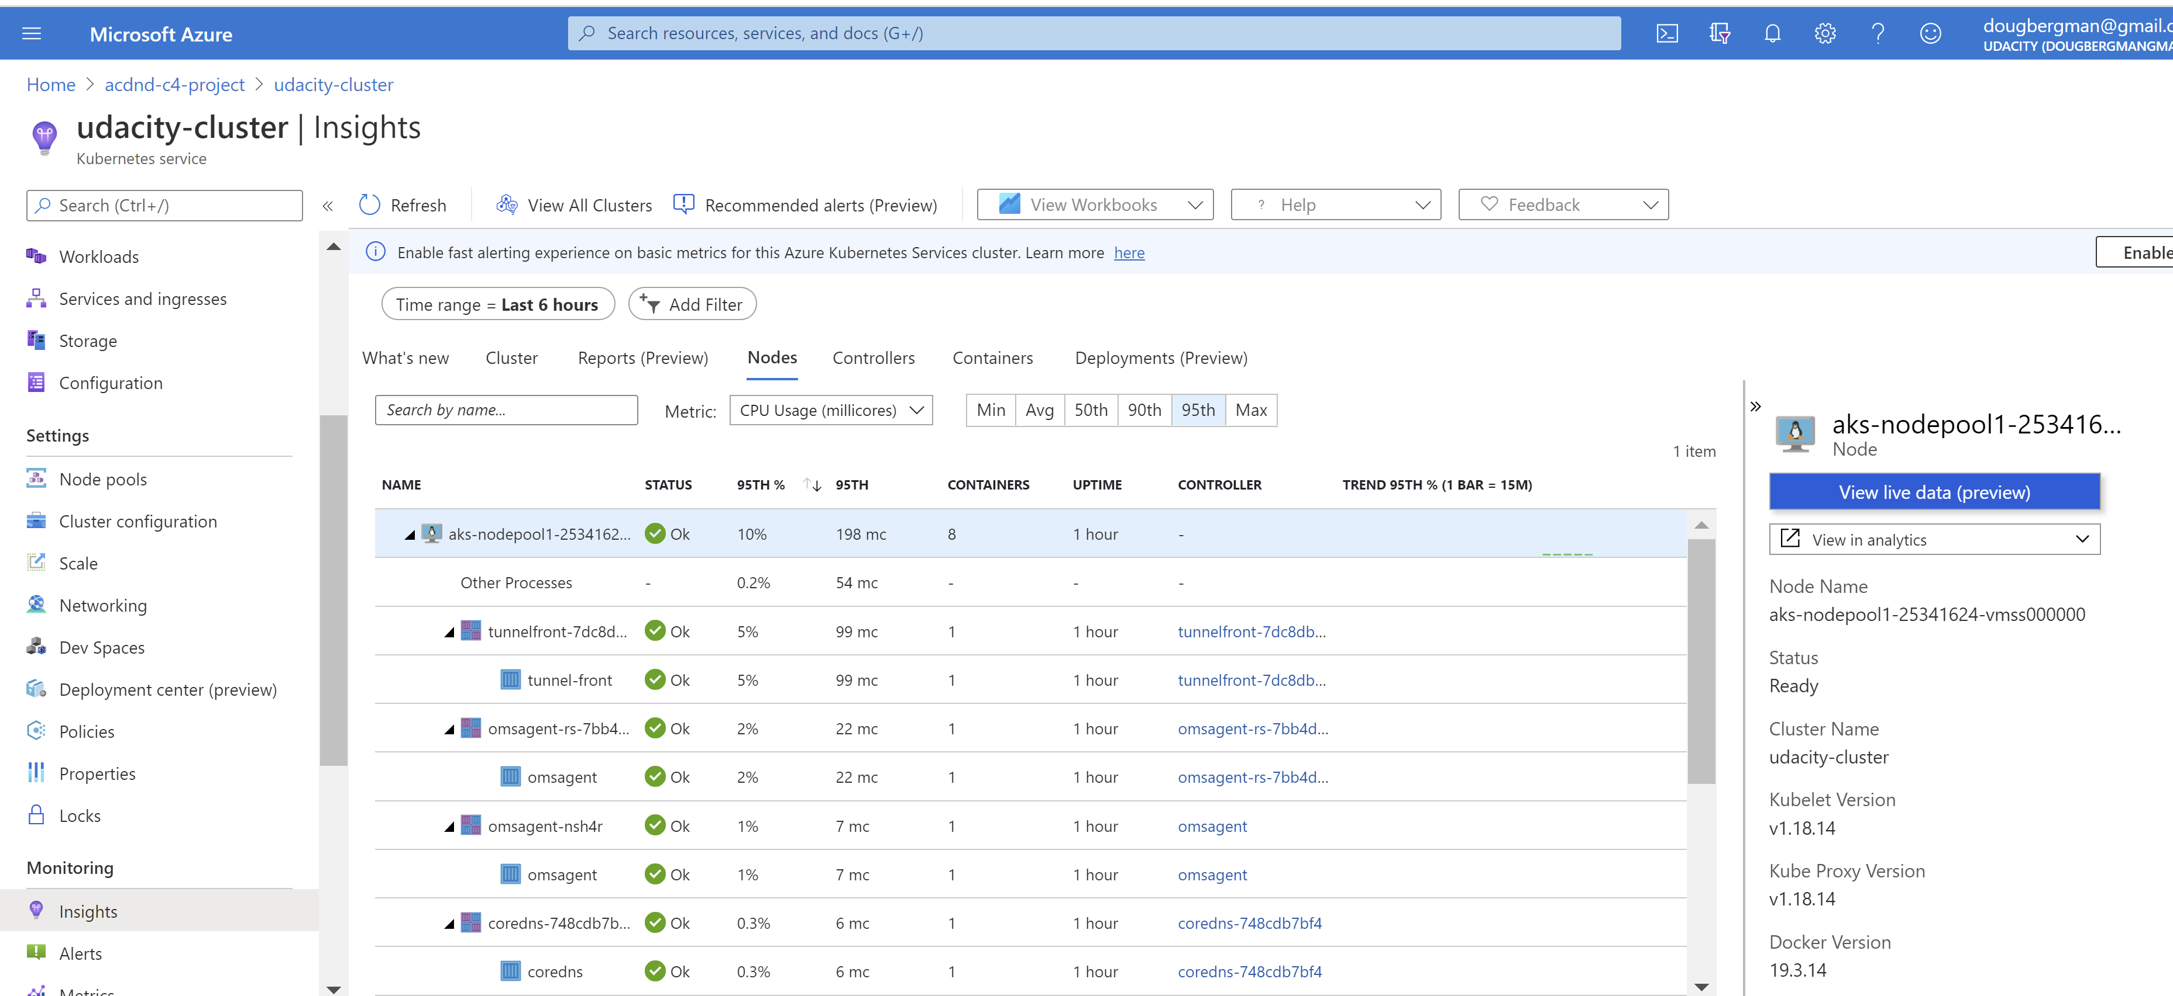

Containers

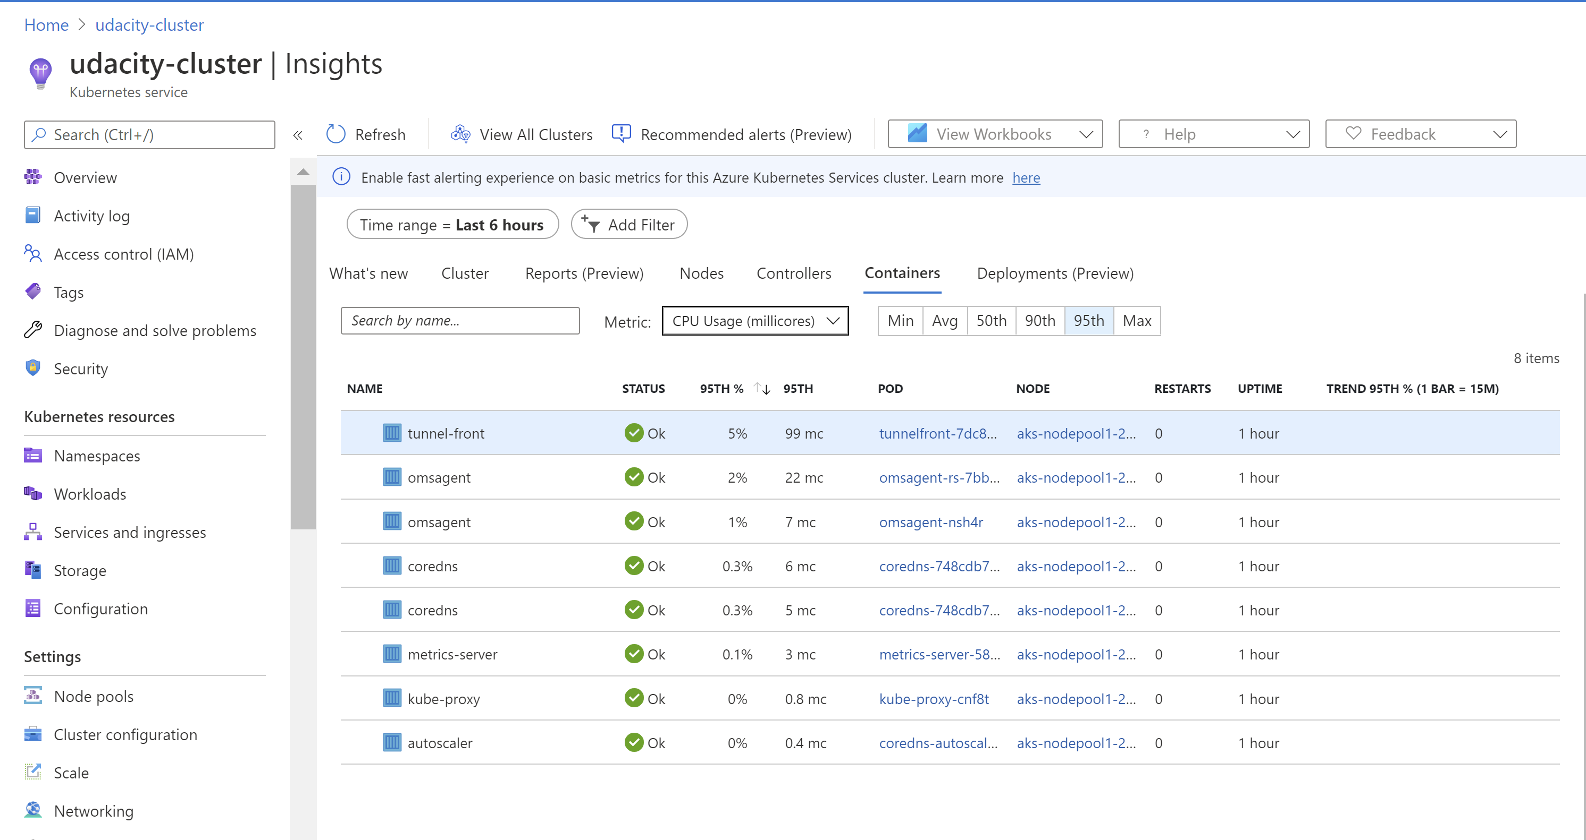

1. Create an alert

As evidence, provide a screenshot of the Azure Alert and email sent when the alert is triggered.

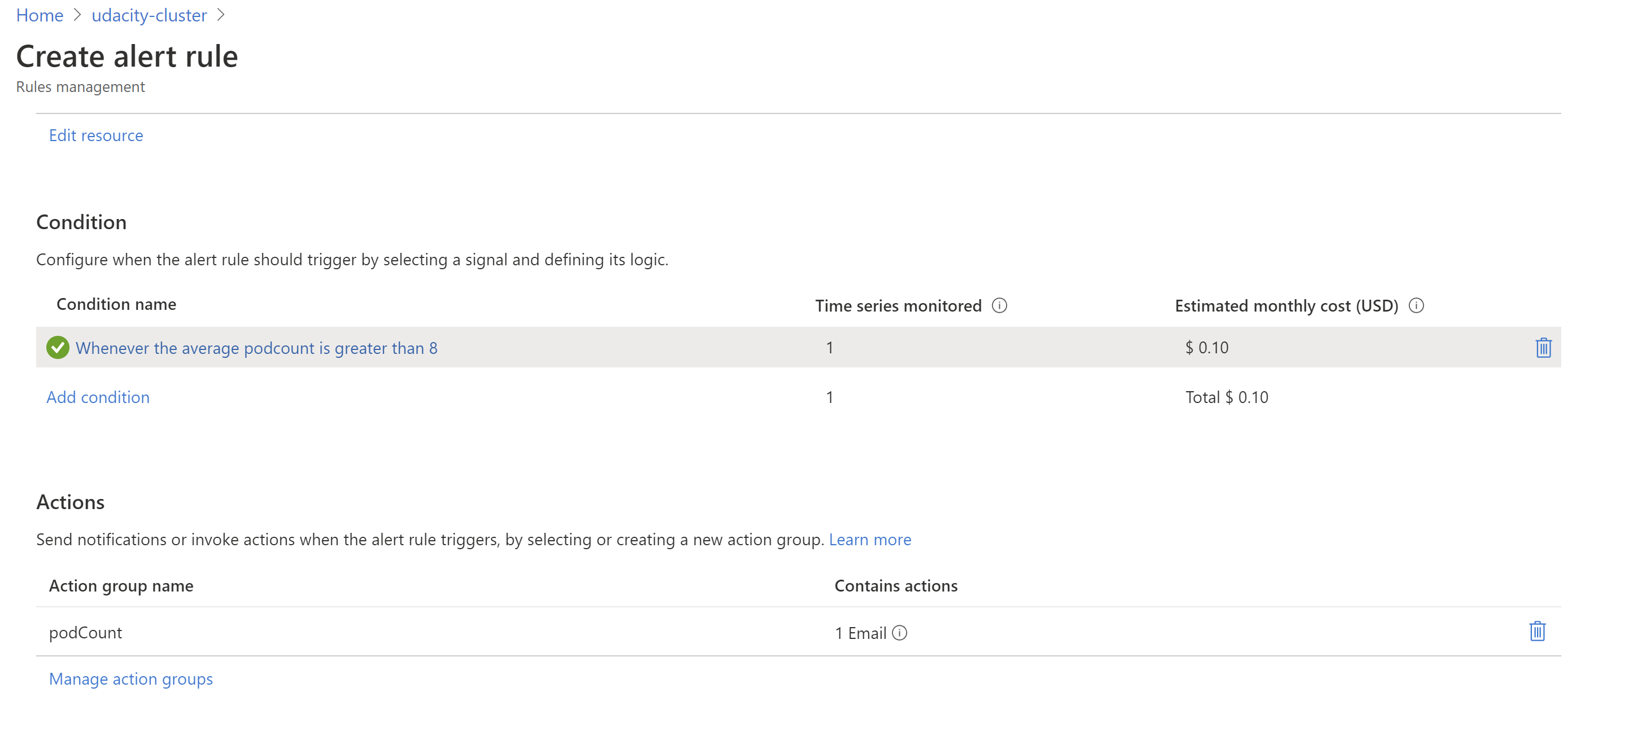

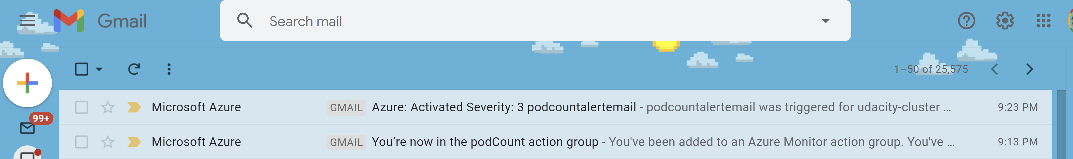

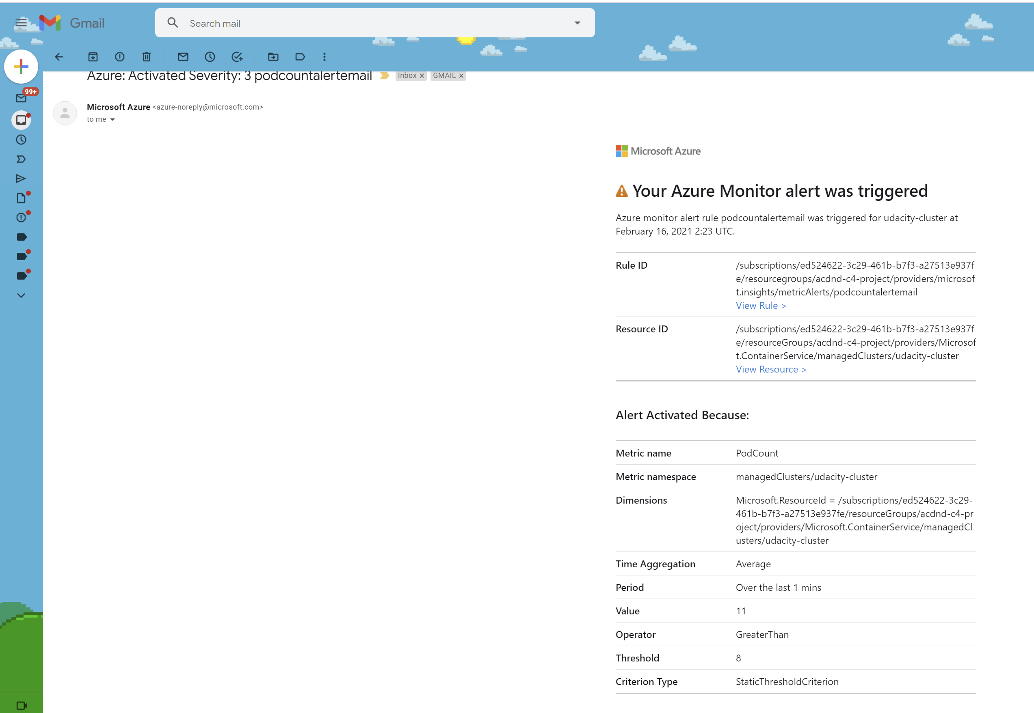

1. Create a horizontal pod auto scaler and cause load on the container.

* The output of the Horizontal Pod Autoscaler, showing an increase in the number of pods.
* The Application Insights metrics which show the increase in the number of pods.
* 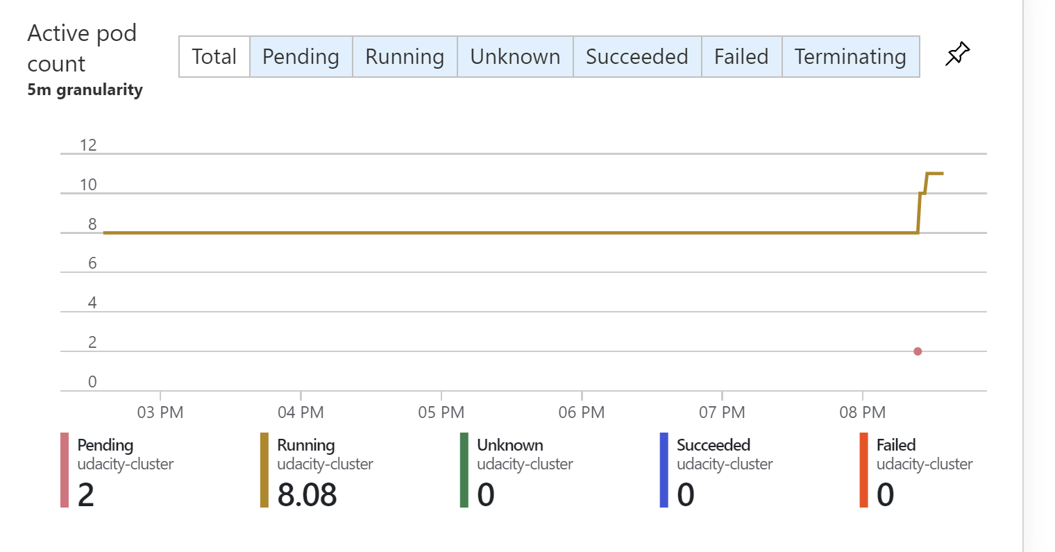
* 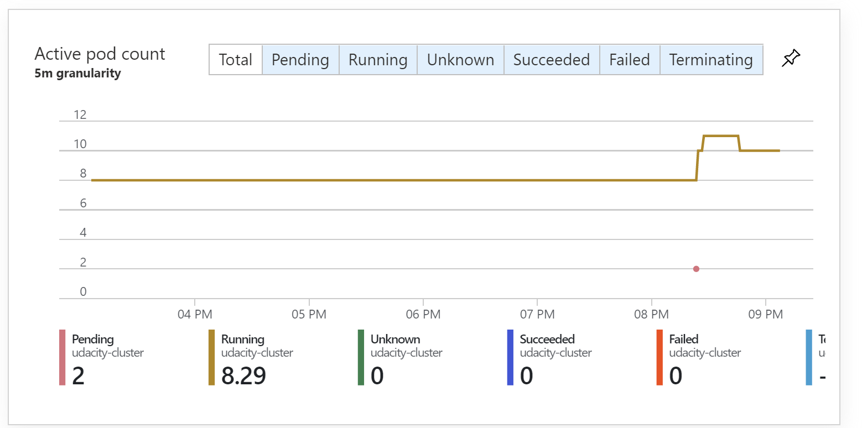
* The email you received from the alert when the pod count increased.
* 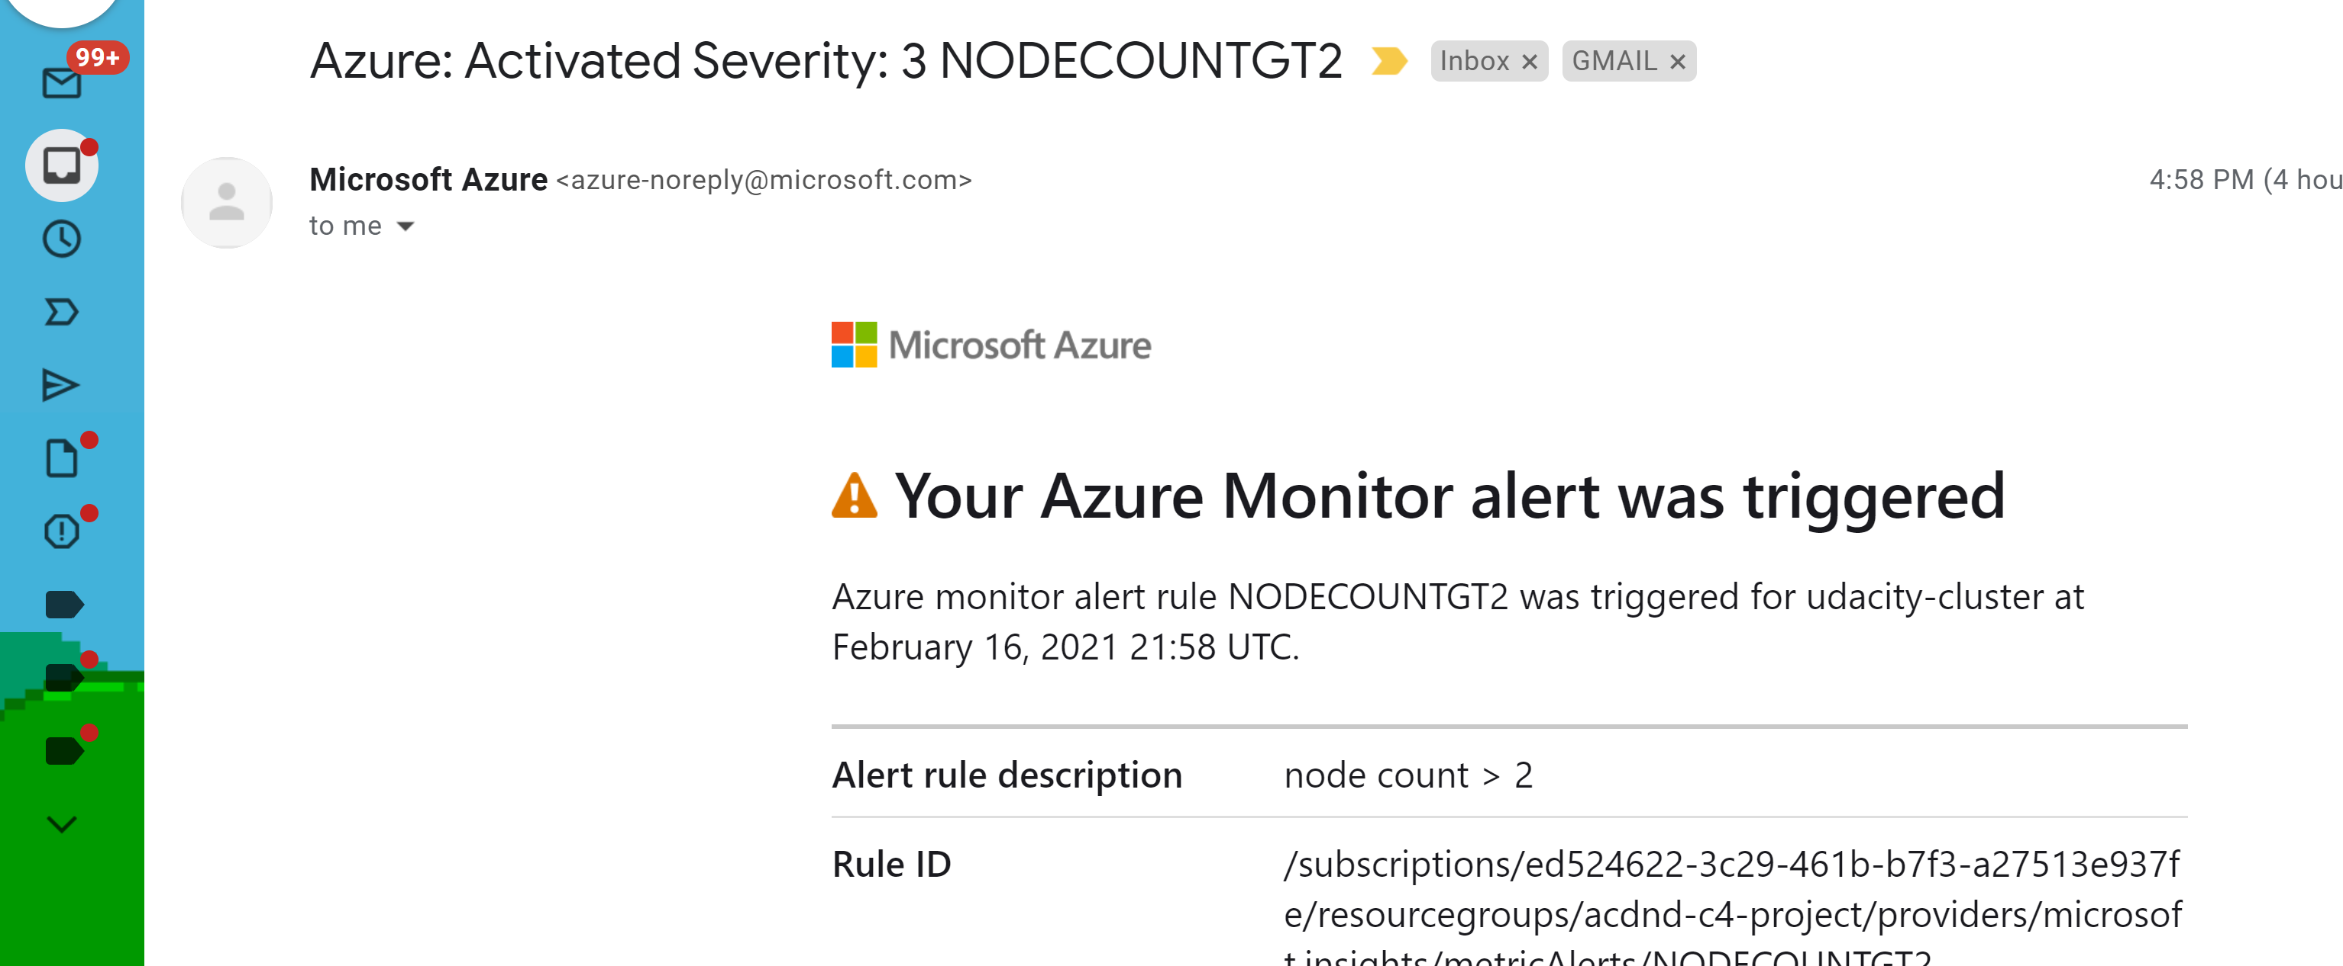

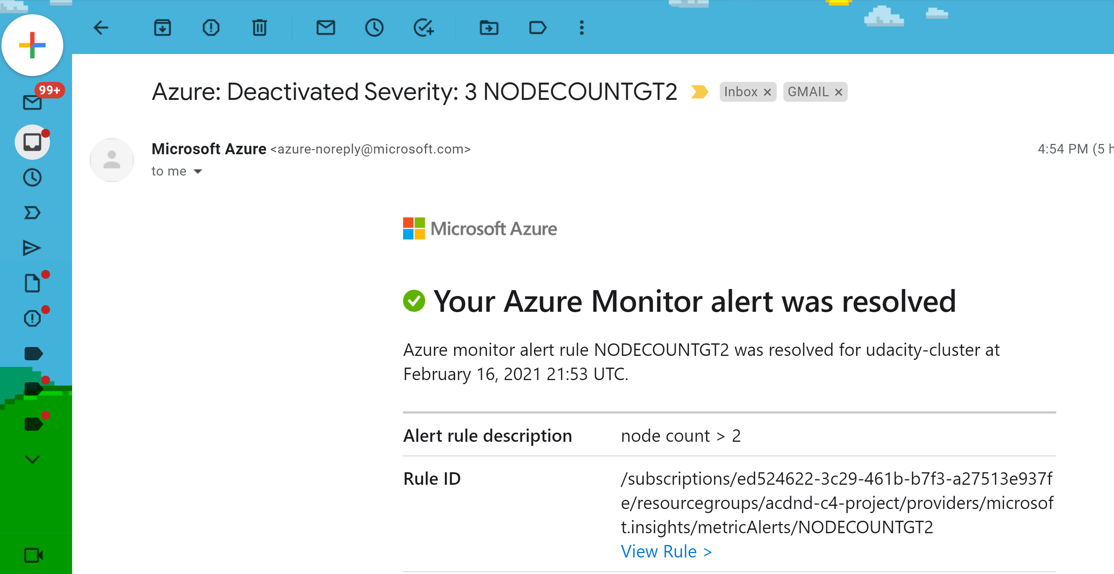

6, Import and reference the correct libraries to enable the collection of Application Insights telemetry data.

* Application Insight Events that show the results of clicking **vote** for each **Dogs** & **Cats**

**(Doug not sure if this is the right screenshot)**

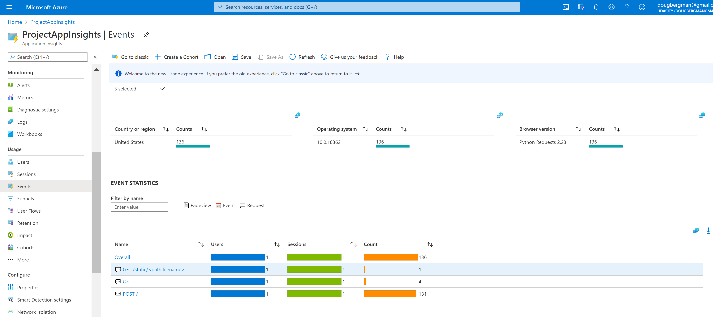

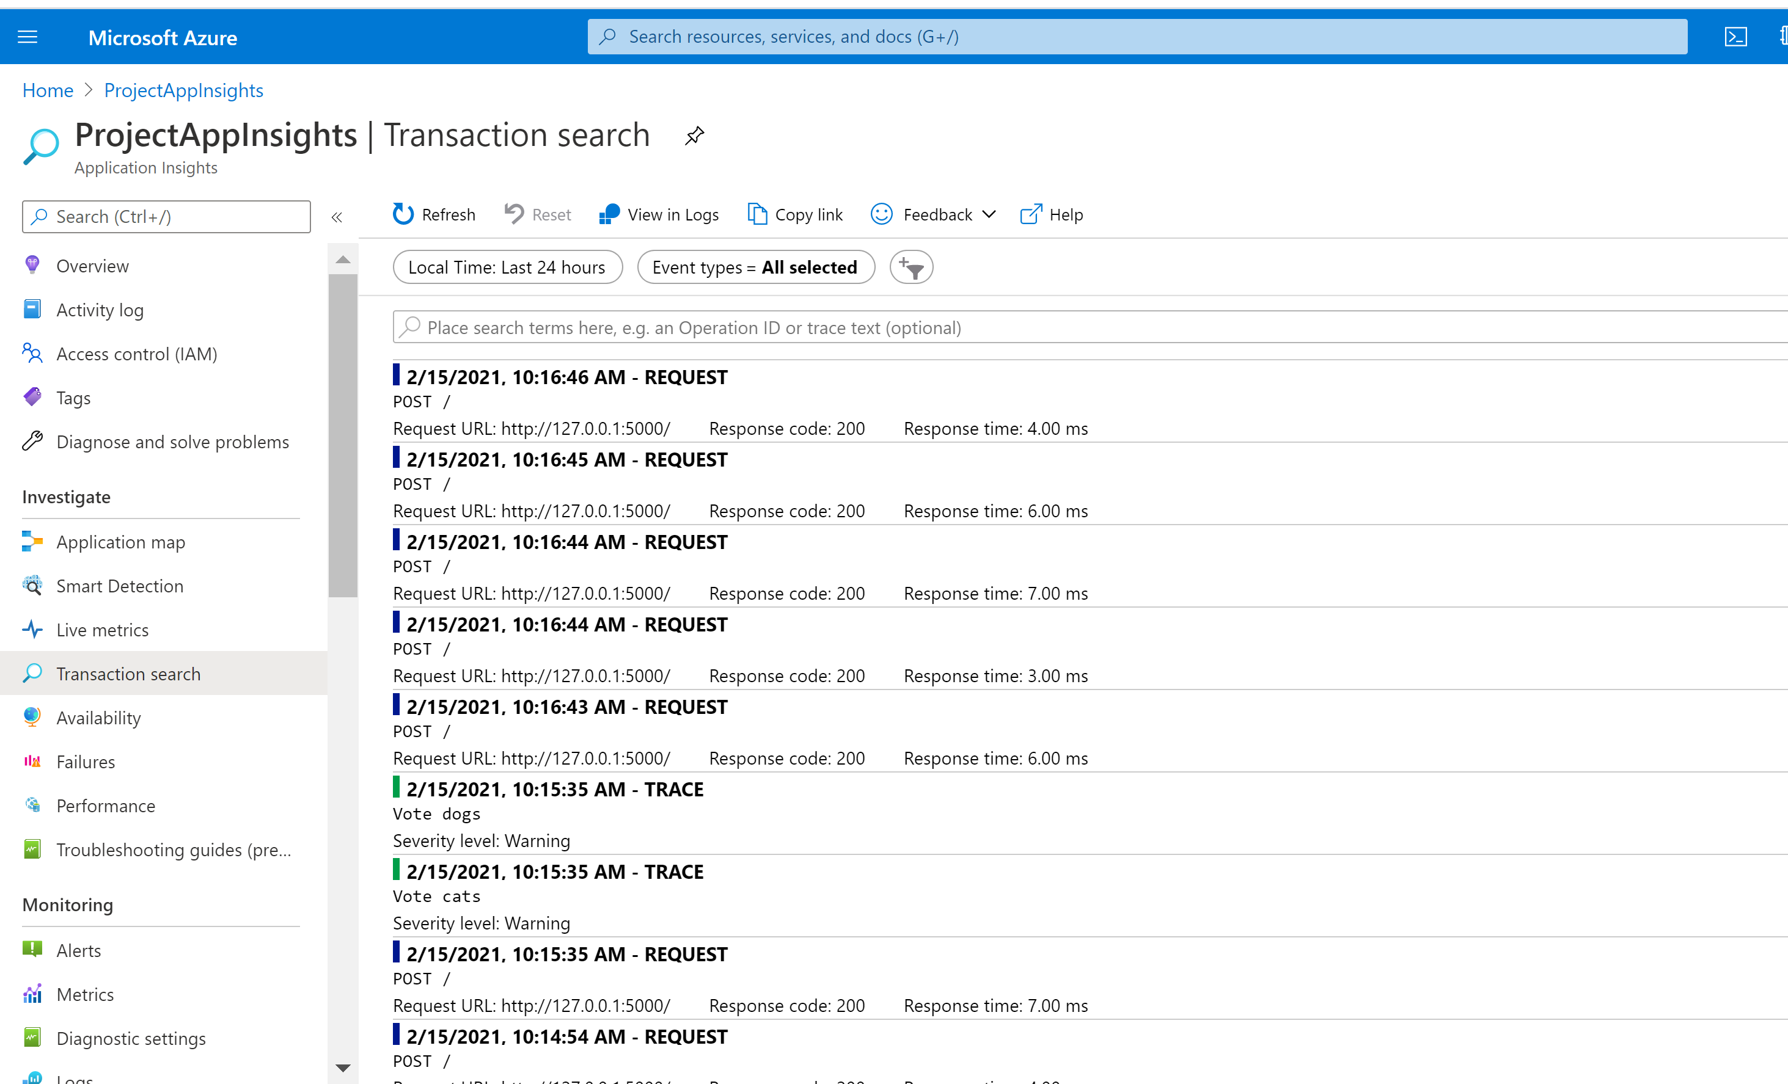

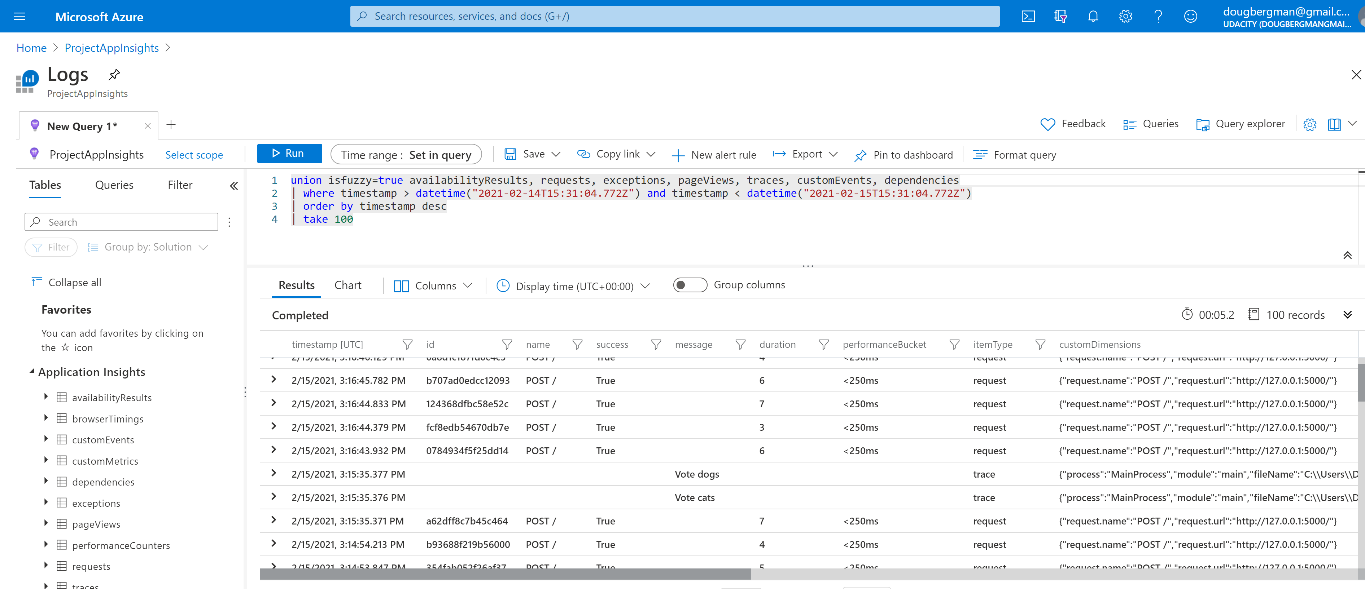

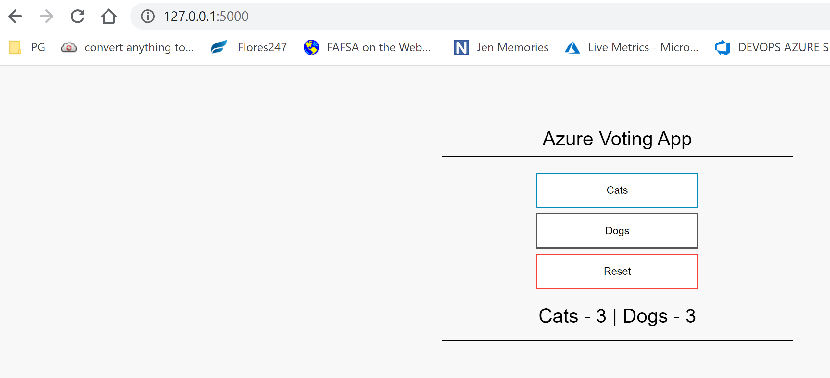

* The output of the **traces** query in Azure Log Analytics

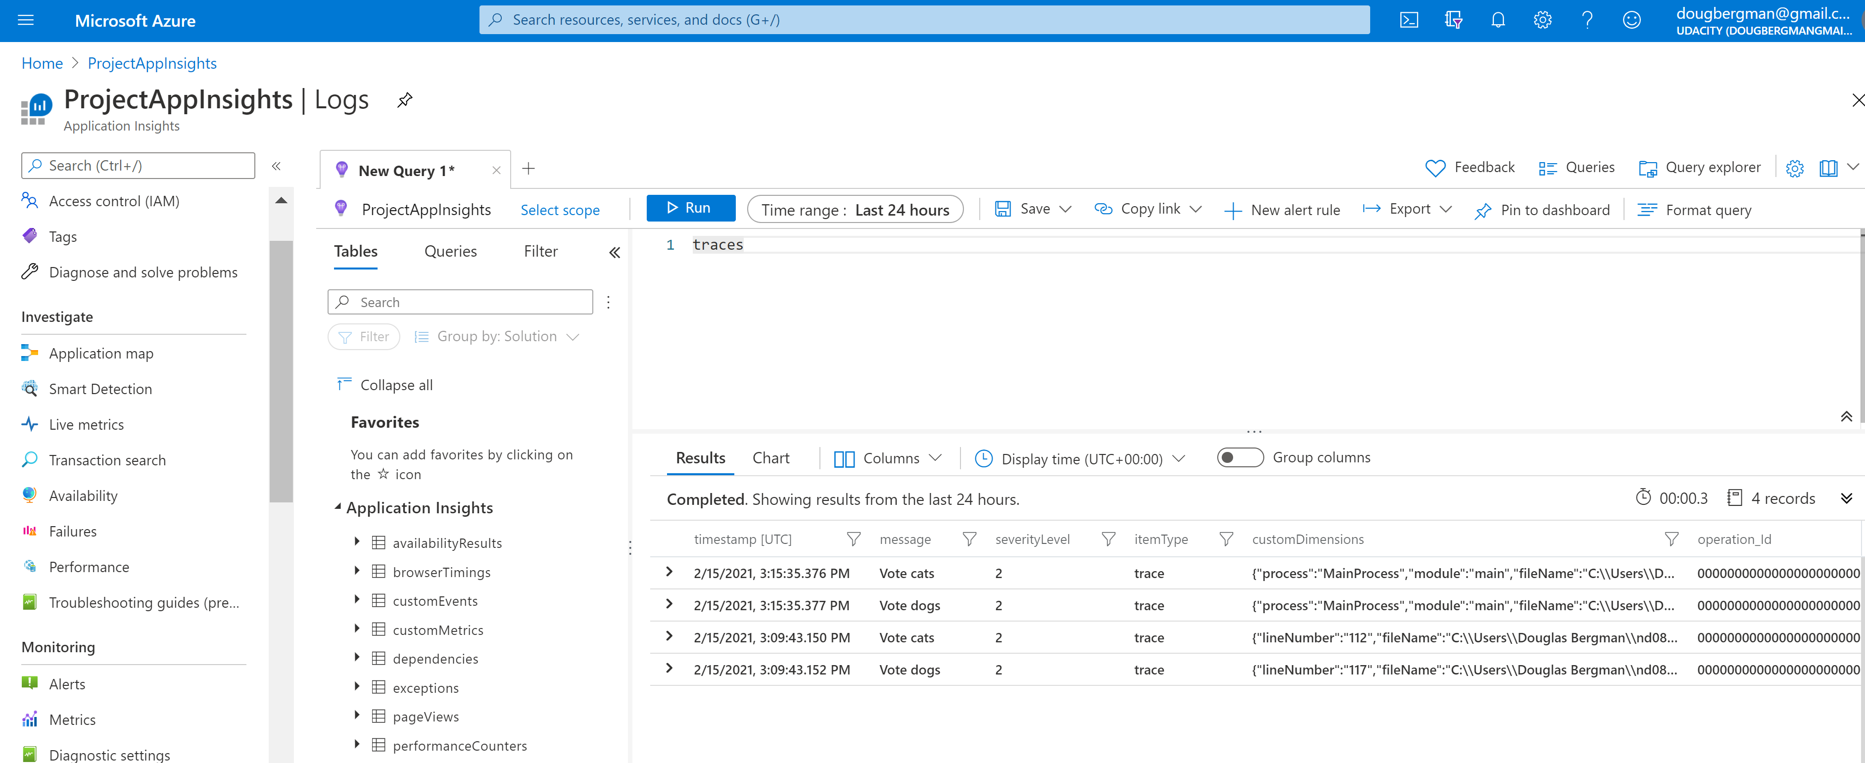

* The chart created from the output of the **traces** query
* 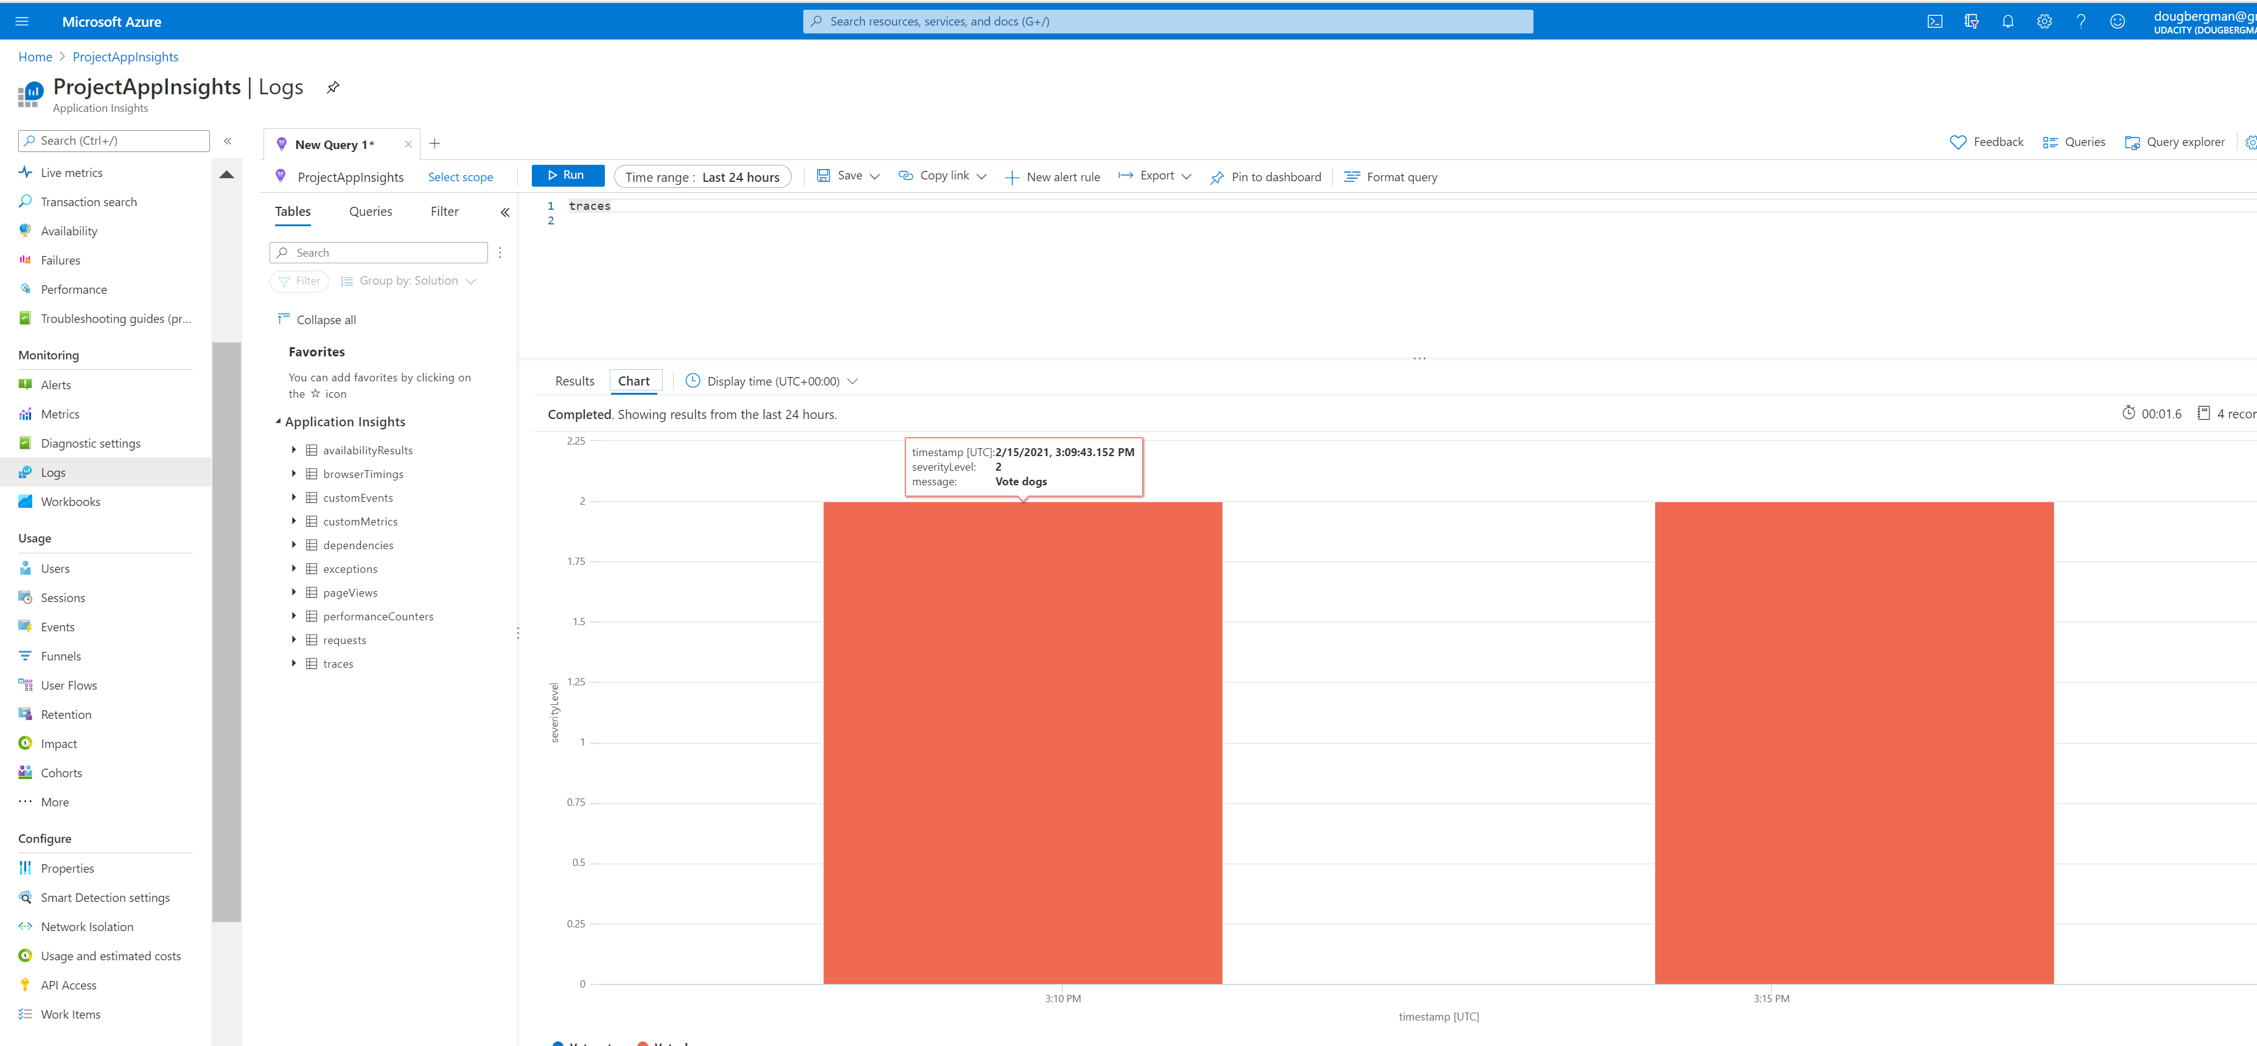

1. Create an auto scaling rule for a VM Scale Set.

Evidence of conditions of rule

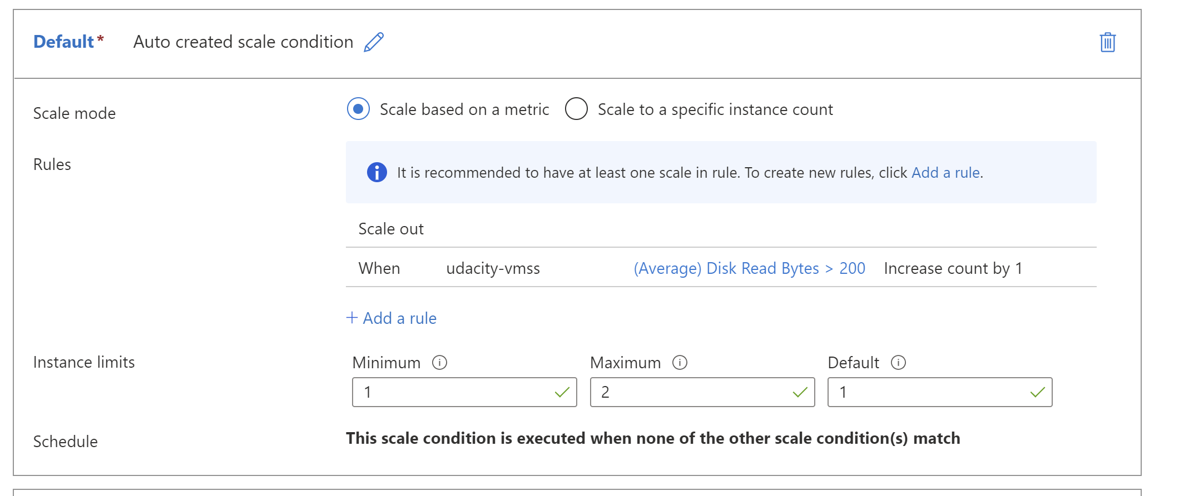

* The Activity log of the VM scale set that shows it scaled up, including a timestamp.
* The new instances being created.
* The metrics showing the load increasing, then decreasing once scaled up, including a timestamp.

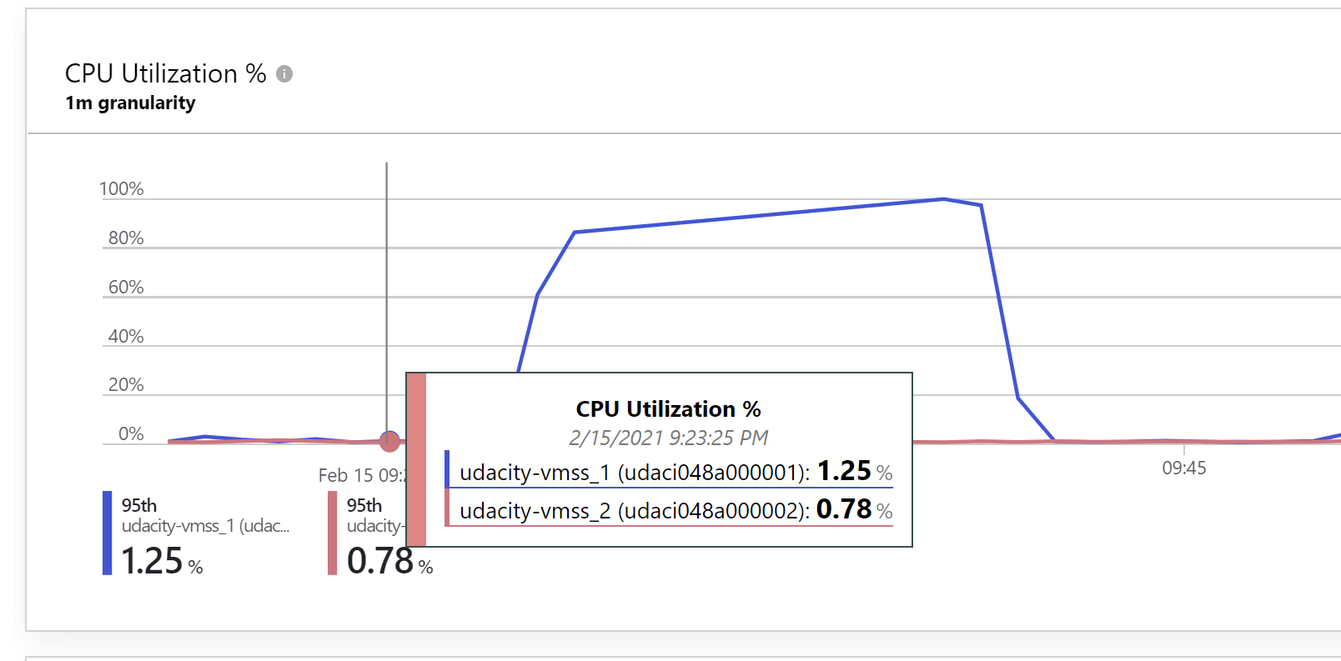

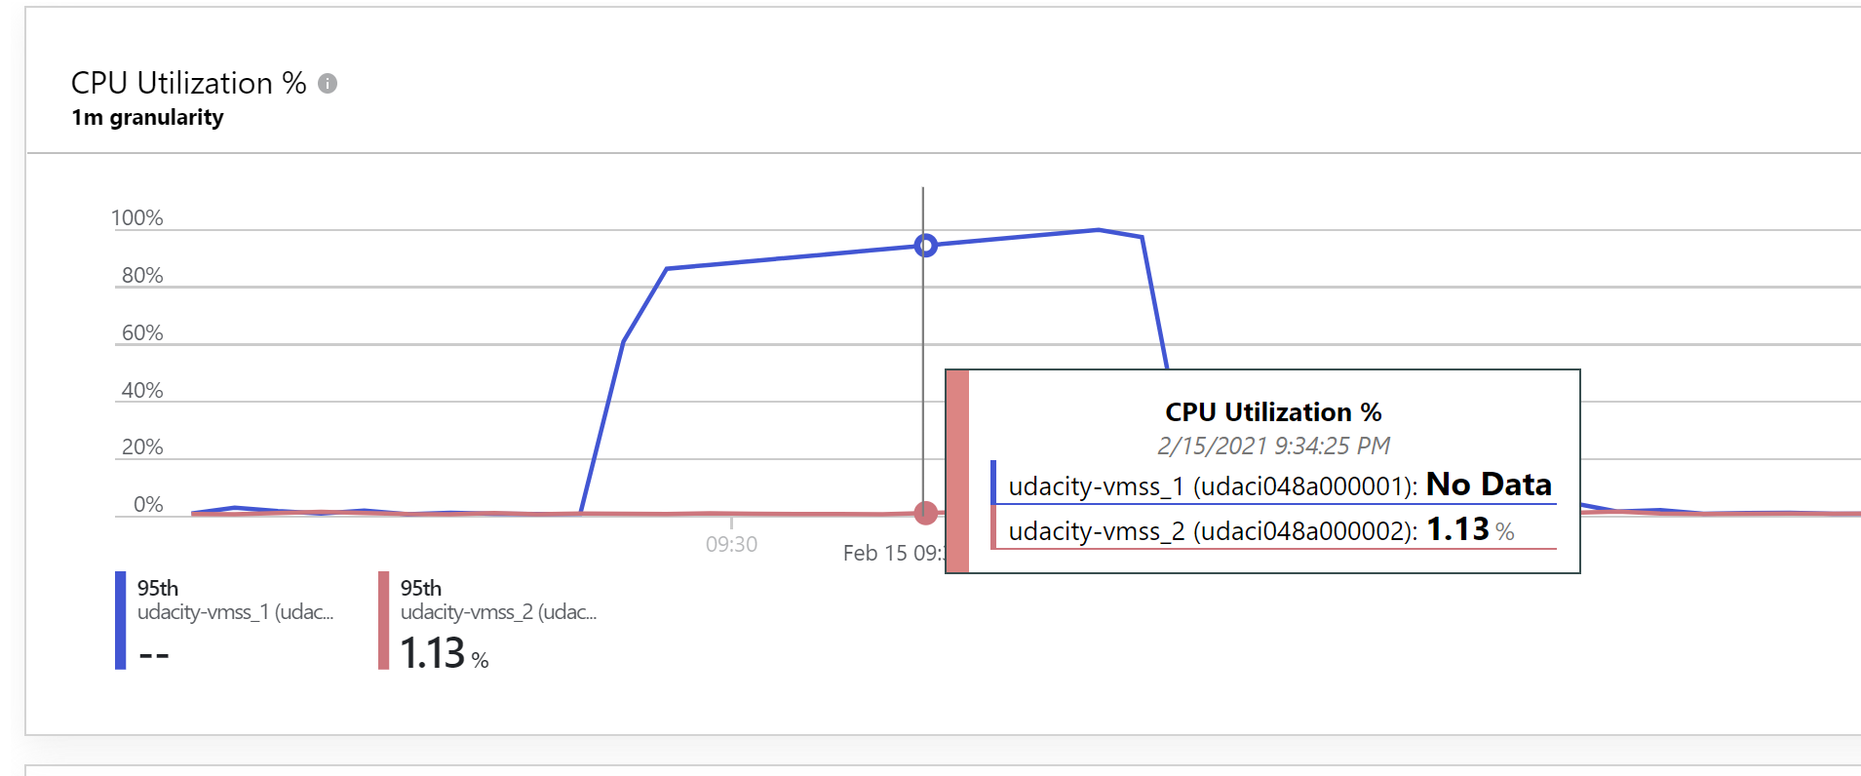

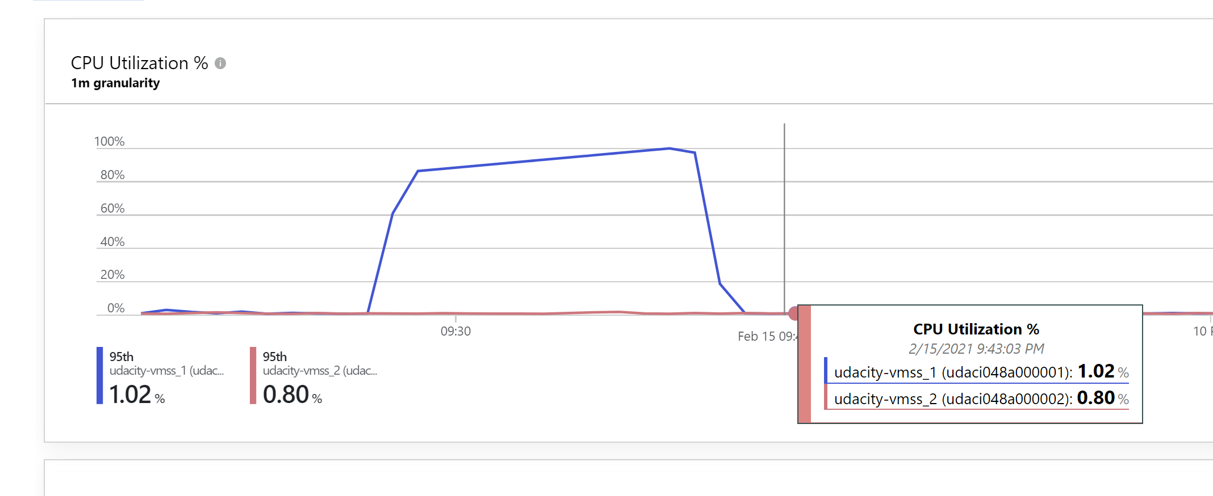

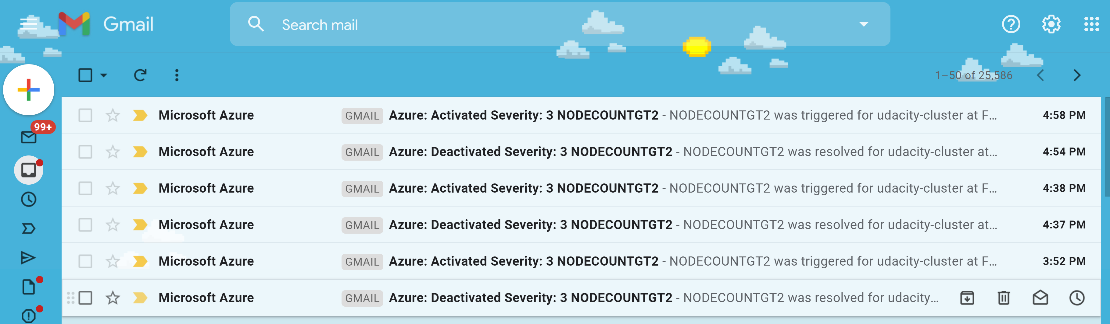

1. RunBook

Create an Azure RunBook to be executed by an Azure Automation Account.

As evidence, provide a screenshot of your resource group containing your running resources.

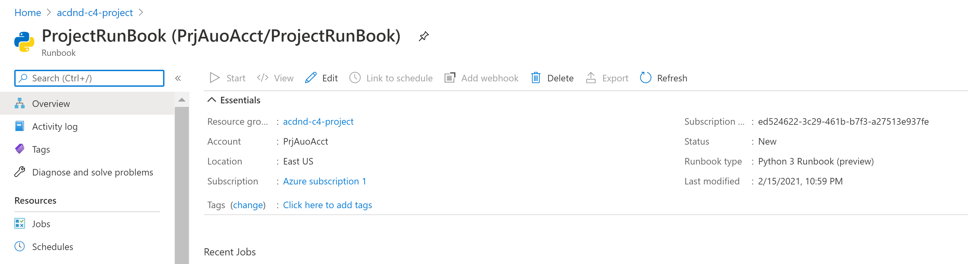

Configure an Azure Alert to trigger the RunBook to execute.

As evidence, provide a screenshot of the configuration.

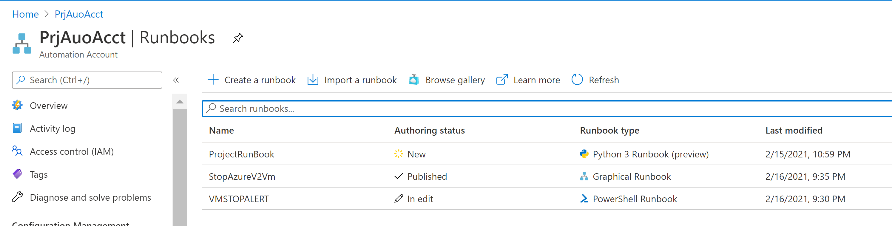

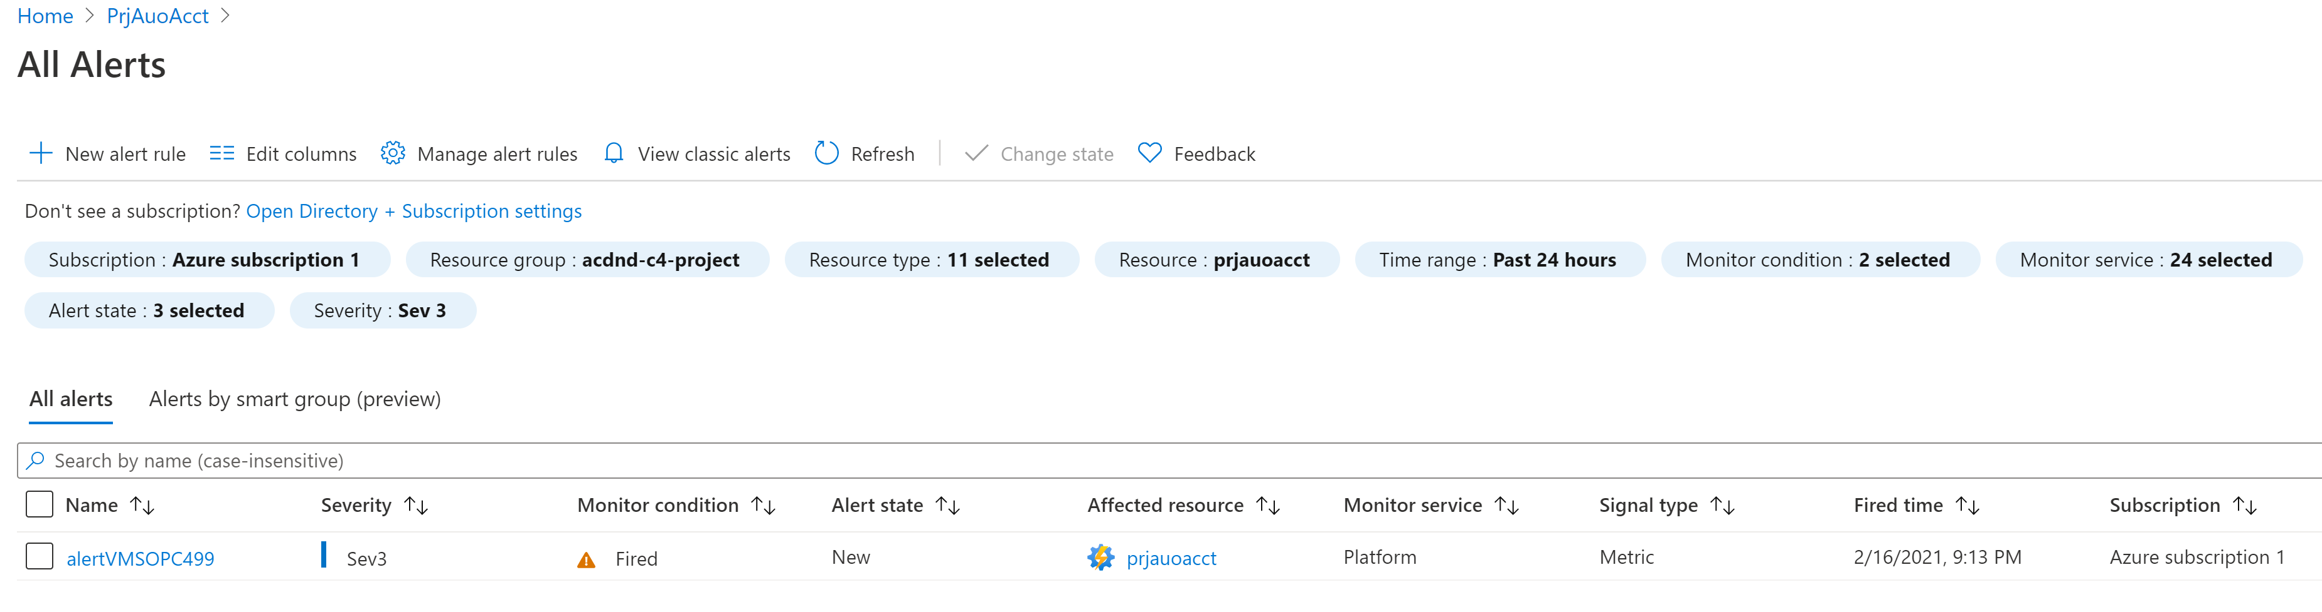

9. Configure an Azure Alert to trigger the RunBook to execute.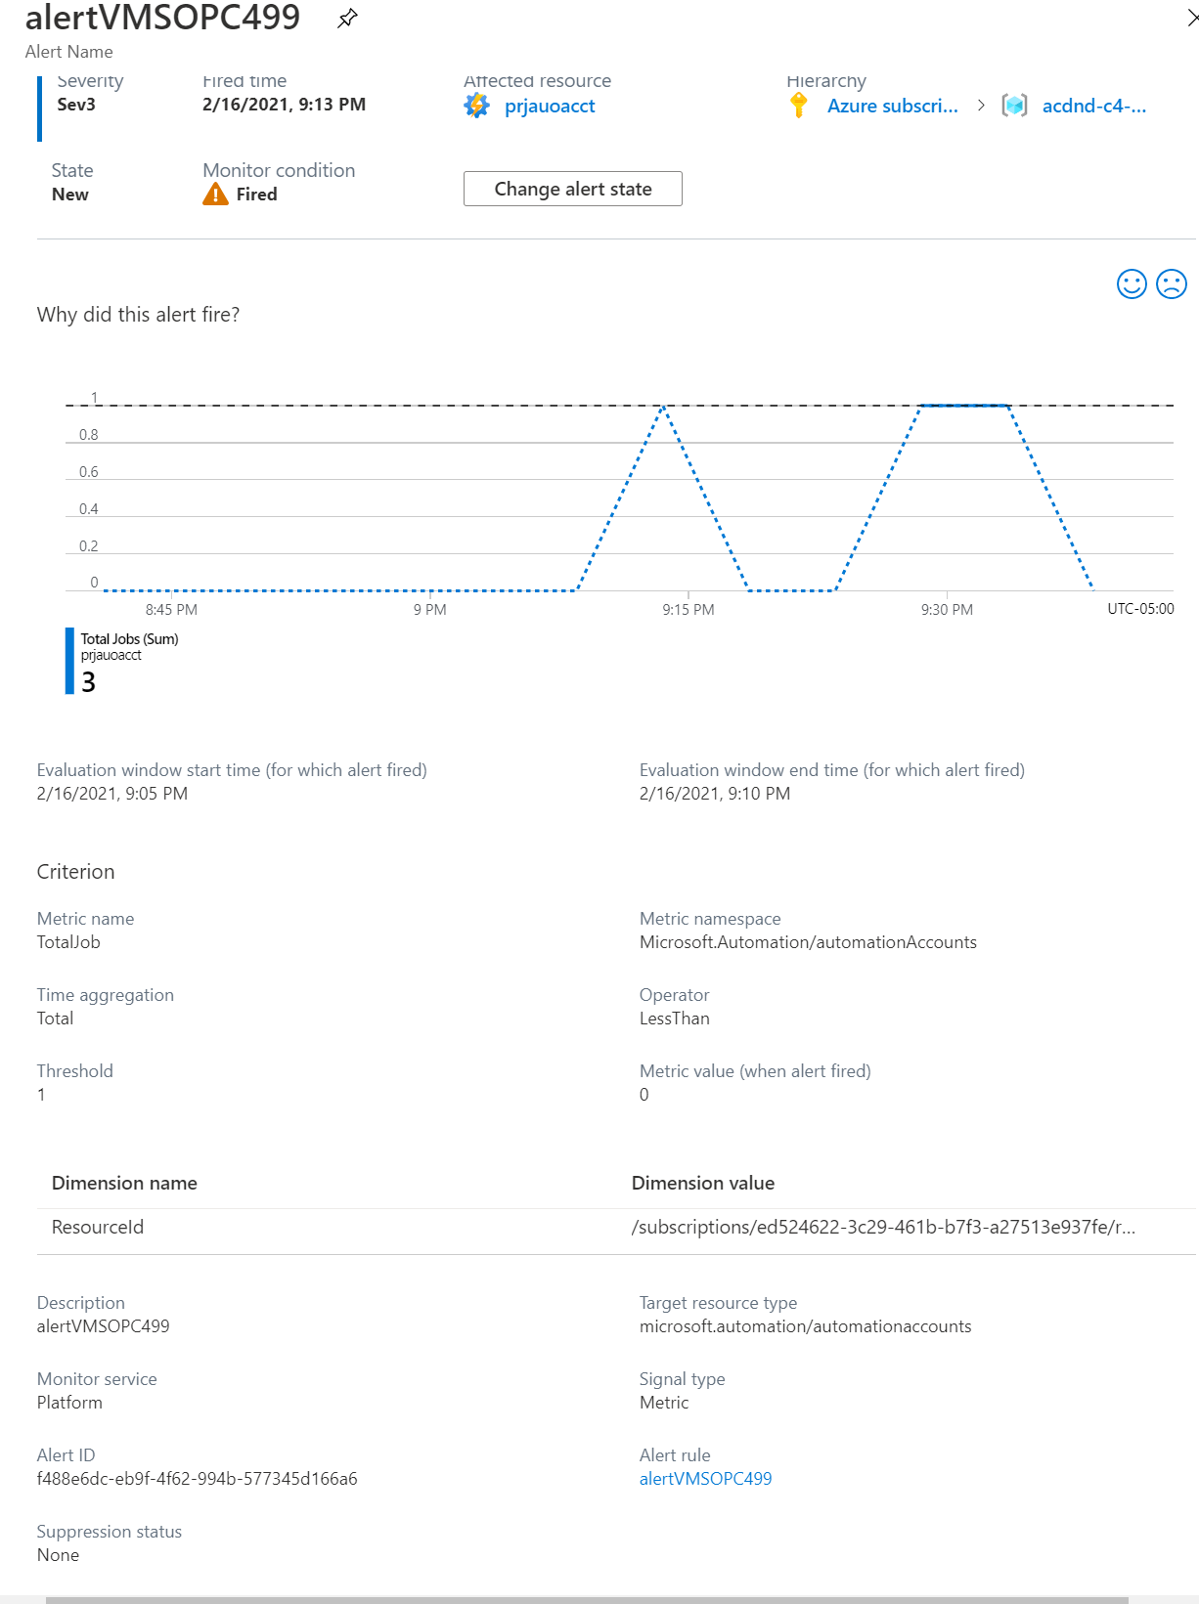

1. Cause the RunBook to be automatically triggered and resolve a problem

* Email showing the alert was triggered
* Metrics or other evidence showing the RunBook executed and resolved the issue.

Rule enabled

